Advocate Link Guide
Important Advocate Link Terms:
Logs – these are the efforts or actions you commit to your CASA and/or ERH assignment over the period of a month. Each action will be its own log. For example, if you attend a team meeting without the youth, that will be a log. If you spend time with the youth later that day, that will be recorded as a different log. Each log will be divided into advocacy areas. Logs should be entered as they occur to ensure accuracy.

Monthly Surveys – while logs are based on actions over the month, surveys are used to track each youth’s progress in the six advocacy areas over the month by completing them at the end of each month. Completing surveys means ranking each of the indicators for the youth. You will see the previous month’s rating when completing the current month’s survey.

Bi-annual Survey – these will be completed every six months after you have submitted the final draft of your court report to track progress over the reporting period.

CASE: Youth’s Case – consider this the youth’s SFCASA case; this includes your assignment. All information under the case is related to the youth’s dependency case, such as the hearings and professionals. Most of your data entry and edits will be on the youth’s case.

CONTACT: Youth’s Contact – this appears as a link that is just the youth’s name on the case’s page. Consider this the more personal and un-changing information about the youth, such as family members and demographics. All individuals have a contact, including volunteers, professionals, and youth. A youth’s placement is found here, but you must notify your Case Supervisor if this changes. It is also in the contact that you will add the personal (non-professional) relationships your youth has.

NAMING CONVENTION FOR FILE UPLOADS:
[youth’s initials][document date][type of documents]
Ex. “S.T. 05.24.2018 Transcript”

https://sfcasa.force.com/s/
*You will automatically be logged off after 15 minutes of inactivity.
*When entering any information that is urgent, please contact your Case Supervisor to notify them as well.
*Please make sure to never upload photos of the young person into the database
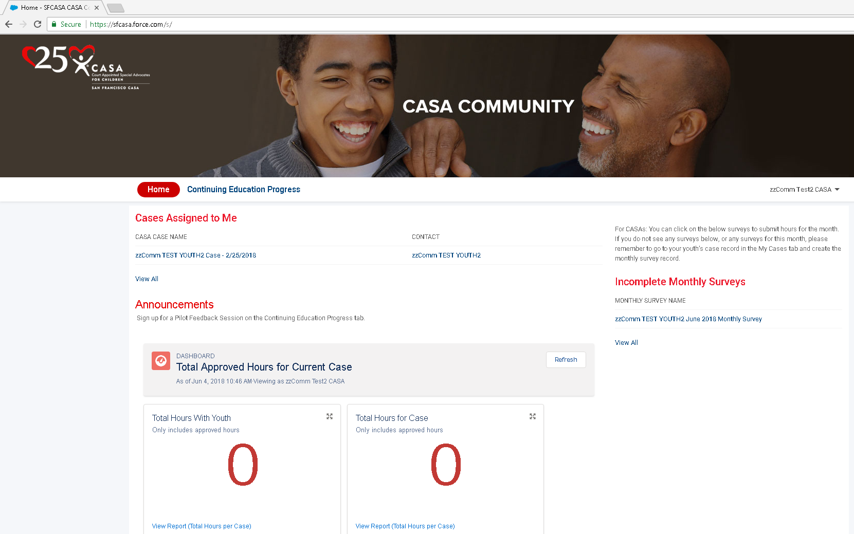

Updating Personal Information
- This is done by clicking the down arrow to the right of your name at the top right of the screen or by clicking your name.
- Then select to Edit Contact Information.
- Select Edit at the top right of this section.
- Update your home address, preferred pronouns, preferred language and all languages spoken (including preferred language) in this section.
  - To update your email address, click on Email & Settings at the left of this section.
- If preferred gender or employer information is inaccurate or changes, please contact your Case Supervisor to share updated information.
  - Note that Other Languages Spoken is a multi-select field. Hold the Control button to click select multiple languages.
- You may upload a photo, but do not upload a photo of your youth.

Uploading Driver’s License and Auto Insurance
- To upload a photo of a renewed or updated driver’s license or auto insurance card/policy, click on the Upload Files button underneath Upload Documents on the right of your screen on your Contact Information page.
- Save the file (email or upload from scan) on your computer with your initials, the date and the document name. (Ex. JD 6.5.2018 Car Insurance).
- Select the file from your computer and click Open.
- When the file has completed uploading, click Done. Click Next.
- To view your uploaded documents, click the link in the text that reads, “To view your uploaded documents, click here.” This links to your personal files.
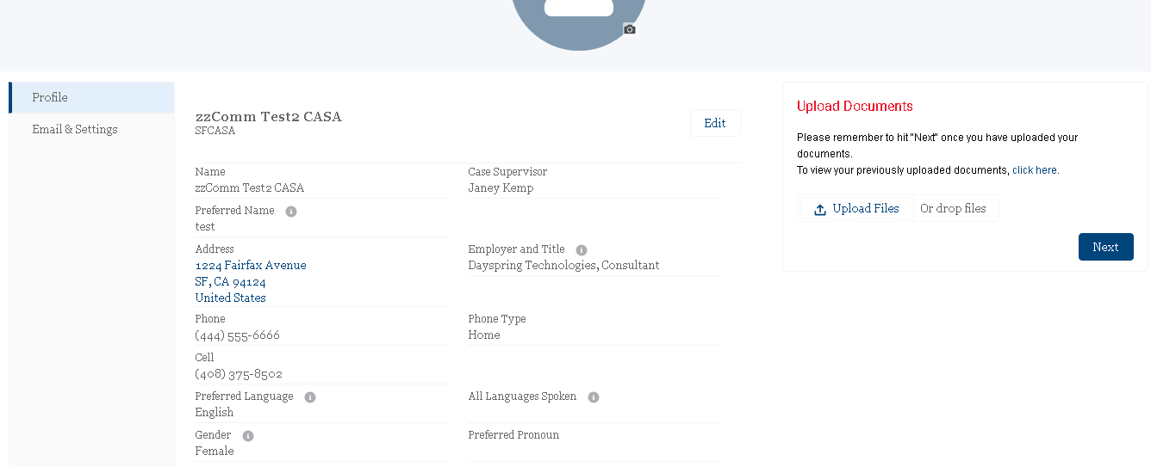
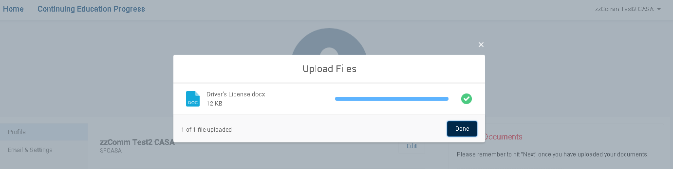
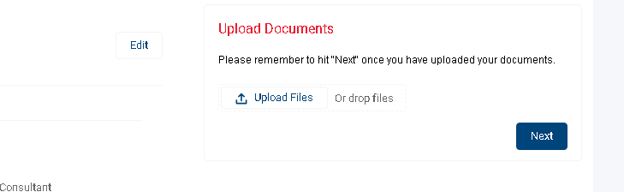

Updating Youth Information
This information must be approved by your Case Supervisor. Once you’ve submitted a change, it cannot be edited until your Case Supervisor has reviewed it.

There are two tabs for your CASA case: Case-Related Information and Case Details. Case-Related Information is where you will be updating a majority of details on your case. All editing will be done by clicking the down arrow to the right of Add Activity/Referral/Employment. If you ever need to return to your case information, click the Home tab at the top of the page.

Updating Youth’s Case Information (in the Case-Related Information Tab)

Add Case (Professional) Relationship Record:
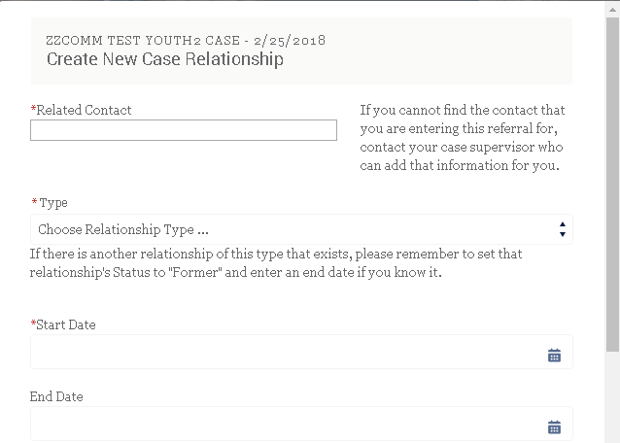
When learning a new professional has been assigned to your youth, using down arrow select Add Case Relationship Record.
- Enter the name of the professional. When you enter the name, enter the first two or three letters of their name and hit enter.
- Select the appropriate professional.
- Choose the relationship type.
- Enter the date of the start of the relationship.
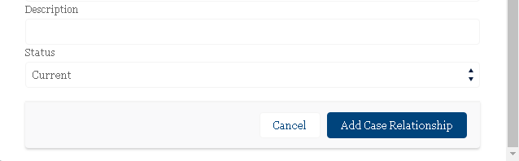
- Click the Add Case Relationship button. This will automatically close the previous professional assigned with the same title unless it is a relationship the youth may have more of such as a therapist. Please discuss with your Case Supervisor.
*If this professional does not appear, contact your Case Supervisor.

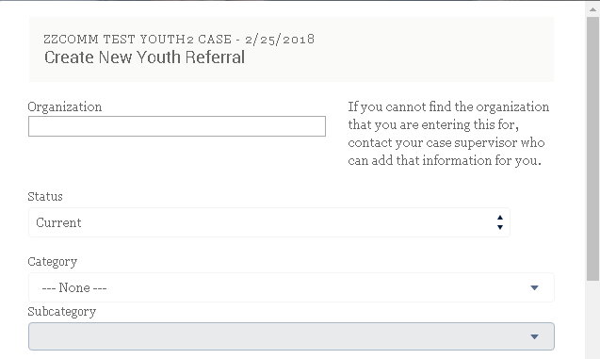
Entering an Organization Your Youth Participates in:
If you are unsure of the type of activity or employment, please contact your Case Supervisor.
- Click Add Activity/Referral Employment at top right of case page.
- Enter the organization name in the organization field until it appears in the drop down field.
- Choose the appropriate category.
- Provide a brief description.
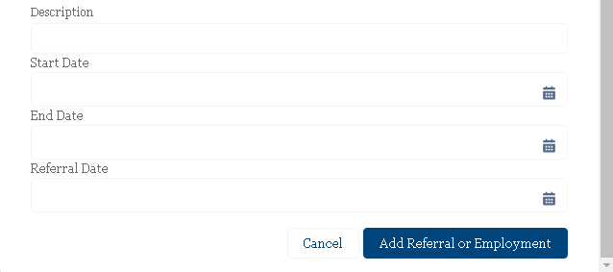
- Enter the start date; if it’s a referral, enter the referral date.
- Click Add Referral or Employment.
*If this organization does not appear, contact your Case Supervisor. Remember to update the end date when youth is no longer participating. The referral date field is only for referrals.

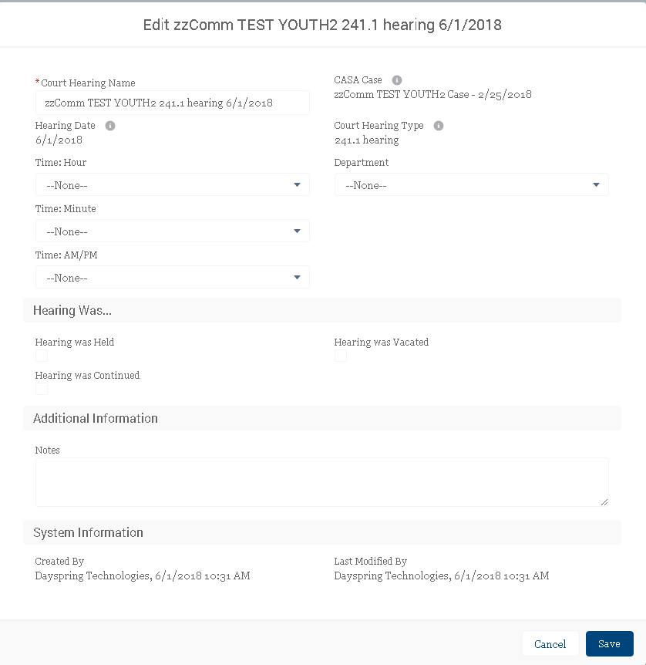
Editing Court Hearing Information:
You can edit court hearing information as needed if there is a change in the time or department.
- Click the down arrow next to the hearing or select the particular hearing you need to edit in the hearings section.
- Update the department or time if either is incorrect.
- After each hearing, check the box indicating whether the hearing was continued, vacated, or heard.
- You will also see here the date the first draft of your court report is due to your Case Supervisor.
- When all necessary editing has been done, click Save.

Viewing Your Court Report, the Status Review Report, or a Hearing’s Findings:
- You will receive an email from the SFCASA program assistant when a court hearing document has been uploaded to Advocate Link for you to view.
- Click on the youth’s case.
- Scroll to the Court Hearings section and click on the hearing for which you want to view the document.
- The document will be found in the Files section at the bottom of the page.
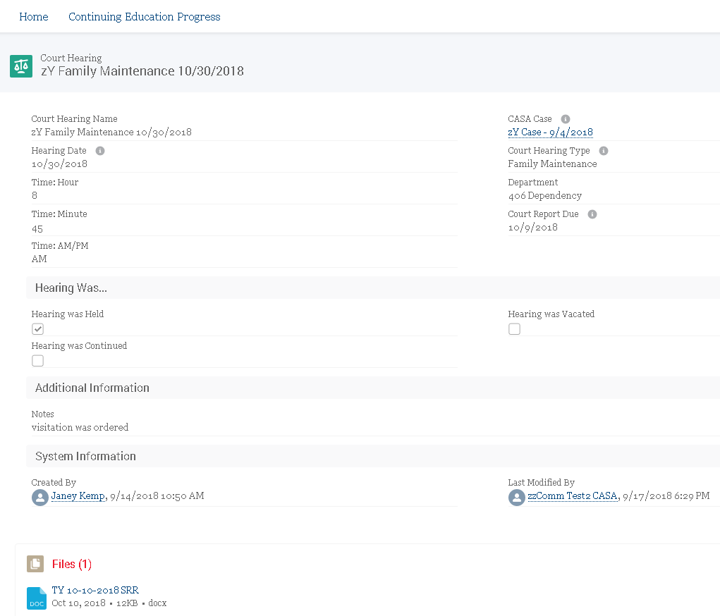

Updating Youth’s Contact Information

Entering Youth’s Contact (Personal) Relationship:
These are relationships of permanency (including family members) rather than professional relationships assigned to the case through the court.
- Click on the youth’s contact.
- Click on the top right button, Add Family/Friend.
- When you enter the name, they will appear in the drop down menu. If they do not appear, they are not yet in Salesforce. You must scroll down to select to Create New Contact.
  - Please enter the information you have about this person.
- Select the type of relationship and then Save.

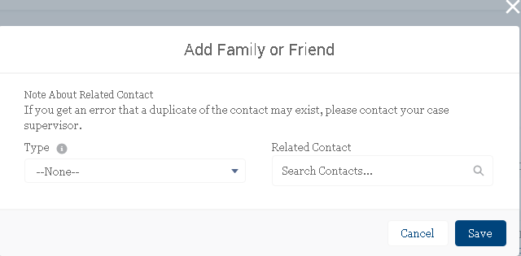
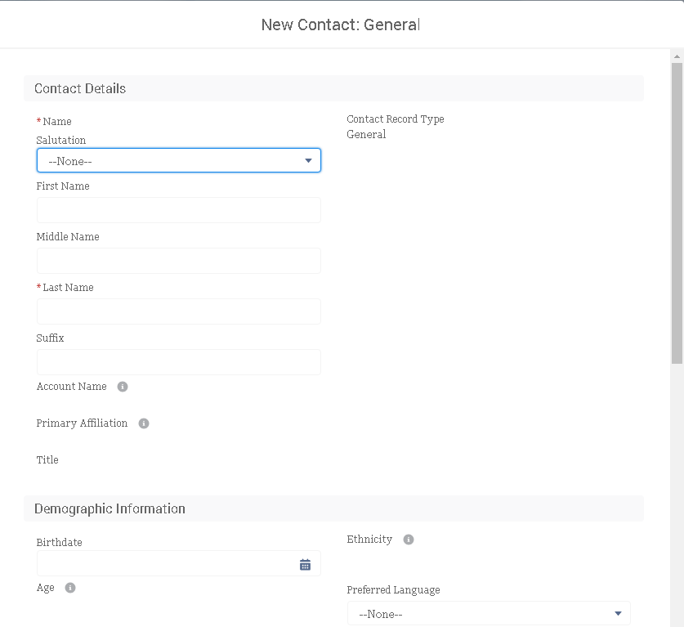

Youth’s Organization Affiliations:
You do not need to edit these. These auto-populate from organizations the youth has been involved with in terms of referrals, activities, and employment.

Creating and Completing Monthly Surveys and Logs
*Always use youth initials only in logs and surveys
A monthly survey will be completed at the end of every month after entering logs for each activity of time spent on the case. To begin entering logs, a survey for the month must be created though you will not be filling out any of the survey until the month has come to a close. Certain questions (under Healthcare, ILS, Education and Career) are not to be completed by those serving youth under 14 years of age. This information must be approved by your Case Supervisor. Once you’ve submitted it, it cannot be edited until your Case Supervisor has reviewed it.

Entering Logs:
- From your youth’s case, click the Create Monthly Survey button at the top right of the page.
- In the pop-up window, enter the month. (The year should auto populate as 2018.)
- When the survey is created, click the link of the survey to enter it or go under Surveys and click the link for the survey month you just created.
- You will see three tabs: Logs, Survey, and Advocacy Help Area. Ignore the Survey tab until the end of the month.
- Click the Add Log Hours button at the top right.
- In the pop-up window, enter the date of the activity.
- Next choose the Contact Type. This may pertain to a Telephone Call, Personal Visit, Case Meeting, or Emails/Texts. (If it’s not applicable, select N/A and enter N/A under Persons Contacted.
- Then enter two or three sentences about how this time was spent.
- Enter Total Hours and Hours with Youth.
- Break up the total hours by percentage of whole in the % of Time in Advocacy Area, using as many as needed.
- To the right, in the Advocacy Area, select from the dropdown what best fits.

  - All contact types and time spent will need to be classified by the appropriate advocacy area: Wellbeing, Permanency, Healthcare, Independent Living Skills, Education and Career, Placement and Housing
  - Please consult the Advocacy Area Help tab and your Case Supervisor should any questions arise regarding how to classify a particular log.
  - Travel time, Administrative work, and Court hearing time options are found in the Advocate Area drop down menu below the six advocacy areas.
- Click Save to submit your log to your case supervisor for review and approval.
- This log will now show up under the Logs tab. You are unable to edit logs while they are pending approval by your Case Supervisor.
*When entering log hours for a case meeting or personal visit, please remember that “travel time” is required as an advocacy area. If you have called in to a case meeting, select the advocacy area of travel time and enter 0%.
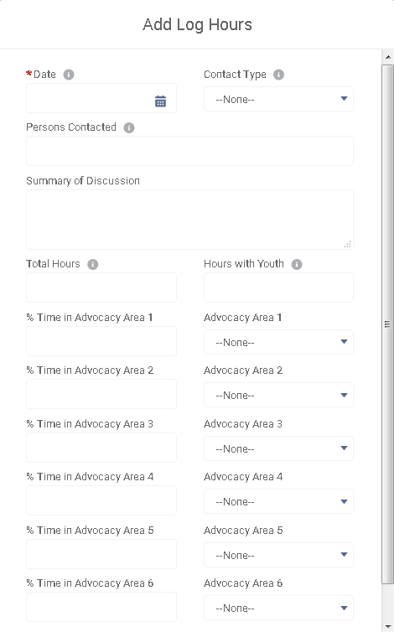
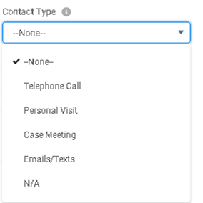

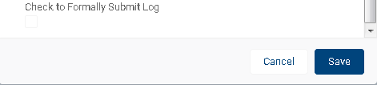
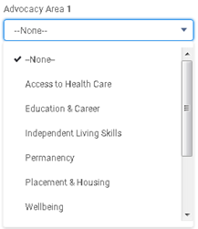
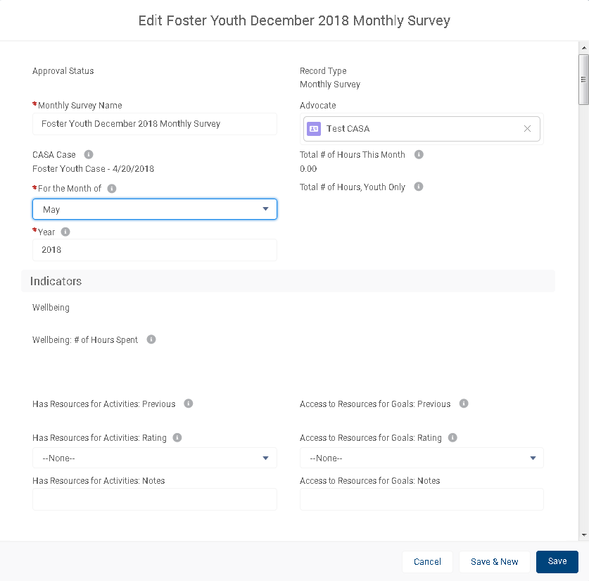
Entering Monthly Surveys:
- Under your youth’s case, scroll down to your monthly surveys. This will show all surveys you’ve created.
- Select the one that you plan to complete.
- Click on the Survey tab to the right of the Logs tab.
- Click the Edit button at the top right.
- You will see that all hours fields will have auto populated from logs you’ve submitted that have been approved by your Case Supervisor.
- For each advocacy area, select a rating and add notes as necessary. (Not all will be required for advocates serving youth who are under the age of 14. Asterisks will appear for those required of all advocates.)
  - Note that above where you are ranking for the current month should populate your ranking for the previous month.
- Complete the miscellaneous information toward the end of the page.
- Check the box to formally submit the log and click Save. (If you’d like to return to the log, do not check the box and just click Save.

Submitting Bi-Annual Surveys
You will be prompted by your Case Supervisor to enter these bi-annual surveys after the completion of your court report and before every hearing. Certain questions will not be required for those serving youth under 14 years of age.

- Click top right down arrow and select Submit Bi-Annual Survey.
- Asterisks will appear for those required of all advocates (including those serving youth under the age of 14).
- After ranking all the indicators click Save.

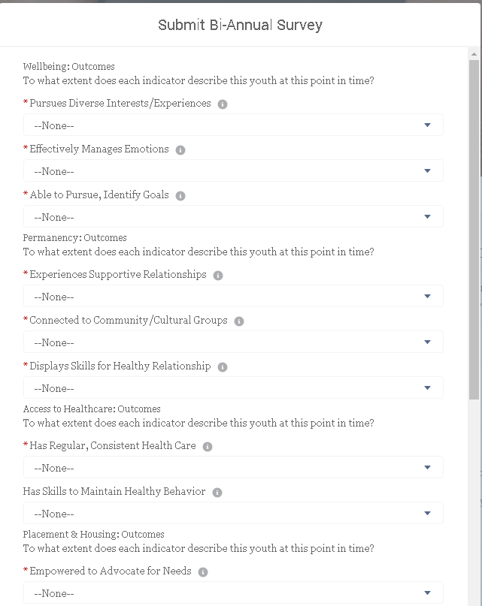

Updating Youth Education Information
This information must be approved by your Case Supervisor. Once submitted, it cannot be edited until your Case Supervisor has reviewed it.

Add/Change PreK-12 School Placement:
This must be done at the beginning of every school year and when your dependent changes schools.
- Navigate to your assigned case and the Case-Related Information tab.
- Click Add School Placement (PreK-12) button at top right.
- Under “School”, enter the school name; notify your Case Supervisor if you cannot find this school.
- Under “Placement Date”, enter the date they enrolled at this school.
- Under “Grade Entered”, enter student’s grade level.
- Click Save.

Add/Change College School Placement:
This must be done at the beginning of every school year and when your dependent changes schools.
- Navigate to your assigned case and the Case-Related Information tab.
- Click the down arrow at top right and select Add School Placement (College).
- Under “School”, enter the school name; notify your Case Supervisor if you cannot find this school.
- Under “Placement Date”, enter the date they enrolled at this school (or the first day of school year for subsequent years at same school).
- Under “Grade Entered”, enter student’s grade level. (If you have questions regarding current grade level, please contact your Case Supervisor)
- Click Save.

Add Education Plan Referral:
When learning your youth has been referred for an IEP, IFSP, or 504 Plan, you will enter this information. You will likely come back to edit this status and will not have all of the information at once! If the youth is approved for assessment by the school, please acquire a copy of the assessment plan from the Educational Rights Holder (ERH) or school.
- Navigate to your assigned case and the Case-Related Information tab.
- Click the down arrow at top right and select Add Ed. Plan Referral.
- Under “Date of Referral”, enter when the referral was submitted to the school.
- Under “Referrer”, enter who made the referral. Follow the instructions on the screen for adding a contact or contacting Case Supervisor for assistance.
- Under “Relationship to Youth”, select the relationship of the referrer to the youth.
- Under “Assessment Status”, indicate if the school approved/denied the request.
- Under “Assessment Approved/Denied Date”, enter the date the decision in step 6 was made.
- Under “Assessment Approval by ERH Status”, indicate if the Educational Rights Holder (ERH) approved/denied the assessment plan.
- Under “Assessment Approved/Denied by ERH Date”, enter the date the decision in step 8 was made.
- In the Assessment check box area, please indicate all assessments checked on the assessment plan.
- Under “Assessment Result”, select the appropriate response based on the assessments.
- Click Save.

Add IEP—Part 1:
If your youth has an IEP meeting, you will enter this information. Please request a copy of the IEP from the school. If you are having difficulty understanding the IEP document to input the record, please contact your Case Supervisor.
- Navigate to your assigned case and the Case-Related Information tab.
- Click the down arrow at top right and select Add IEP Record.
- Under “Meeting Date”, enter the date of the IEP meeting.
- Under “Program Type”, select the appropriate category. (This one can be tricky—contact your Case Supervisor if you are unclear)
- Under “School District”, select the school district for the plan.
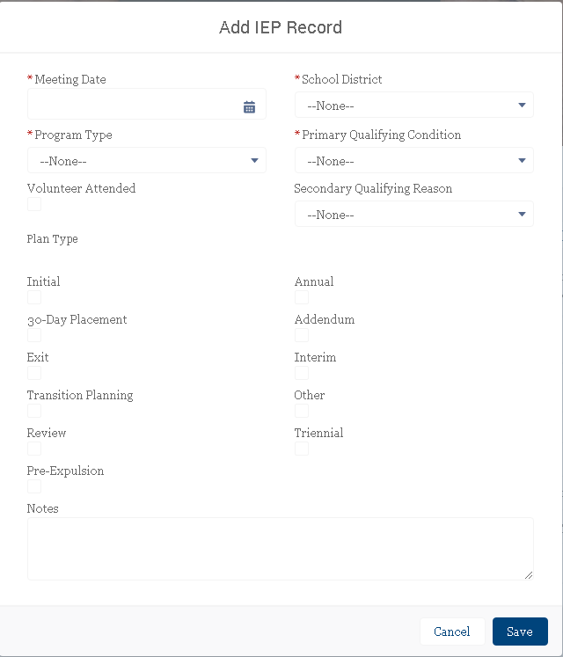
- Under “Primary Qualifying Condition”, please select appropriate category.
- If the youth has two qualifications, please indicate the “Secondary Qualifying Reason” in the dropdown.
- If you attended the meeting (even by phone), check the box for “Volunteer Attended”.
- Under “Plan Type”, please check all of the appropriate options indicated on the IEP document.
- Be sure to use the “Notes” section to include any additional information related to the meeting/plan. You will be able to see these notes later.
- Click Save.

Add IFSP—Part 1:
If the child has an IFSP meeting, you will enter this information. Please request a copy of the IFSP from the school. *IFSP is ONLY for children under age 3. If you are having difficulty understanding the IFSP document to input the record, please contact your Case Supervisor.
- Navigate to your assigned case and the Case-Related Information tab.
- Click the down arrow at top right and select Add IFSP Record.
- Under “Meeting Date”, enter the date of the IFSP meeting.
- Under “Plan Type”, please select the appropriate option.
- Under “Program Type”, select the appropriate category.
- Under “School District”, select the school district for the plan.
- Under “Primary Qualifying Condition”, please select appropriate category.
- If the child has two qualifications, please indicate the “Secondary Qualifying Reason” in the dropdown.
- If you attended the meeting (even by phone), check the box for “Volunteer Attended”.
- Feel free to use the “Notes” section to include any additional information related to the meeting/plan. You will be able to see these notes later.
- Click Save.

Add IEP or IFSP—Part 2:
To accompany the IEP or IFSP record, please request a copy directly from the school. We will be uploading these documents into Salesforce for record keeping on the Case-Related Information tab and your Case Supervisor will not approve the IEP/IFSP record until this is uploaded. *IFSP is ONLY for children under age 3.
- If there is a photo of the youth on the document, please block out the photo before uploading.
- Save the file (email or upload from scan) on your computer with the youth’s initials, the date of the meeting, and the type of plan. Ex: “MH 3.10.18 IEP”
- Navigate to your assigned case and the Case-Related Information tab.
- Scroll down to the Files section and click Add Files.
- Click Upload Files, select the file from your computer, and click Open.
- After the file is done uploading, click Done and you should now see the document in the Files section.

Add 504 Plan—Part 1:
If your youth has a 504 Plan meeting, you will enter this information. Please request a copy of the 504 Plan from the school.
- Navigate to your assigned case and the Case-Related Information tab.
- Click Add 504 Plan button at top right.
- Under “Meeting Date”, enter the date of the 504 Plan meeting.
- Under “School District”, select the school district for the plan. (If you are having trouble with finding this, contact your Case Supervisor).
- If you attended the meeting (even by phone), check the box for “Volunteer Attended”.
- In the qualifications, select and/or write out all of the qualifications indicated in the 504 Plan document.
- Under “Accommodations/Modifications”, please list out all indicated on the 504 Plan document.
- Feel free to use the “Notes” section to include any additional information related to the meeting/plan. You will be able to see these notes later.
- Click Save.

Add 504 Plan—Part 2:
To accompany the 504 Plan record, please request a copy directly from the school. We will be uploading these documents into Salesforce for record keeping on the Case-Related Information tab and your Case Supervisor will not approve the 504 Plan record until this is uploaded.
- If there is a photo of the youth on the document, please block out the photo before uploading.
- Save the file (email or upload from scan) on your computer with the youth’s initials, the date of the meeting, and the type of plan. Ex: “MH 3.10.18 504 Plan”
- Navigate to your assigned case and the Case-Related Information tab.
- Scroll down to the Files section and click Add Files.
- Click Upload Files, select the file from your computer, and click Open.
- After the file is done uploading, click Done and you should now see the document in the Files section.

Add Discipline Record (PreK-12 only)—Part 1:
When learning your youth has been suspended, recommended for a manifestation determination hearing (special education), or recommended for expulsion, you will enter this information.
- Navigate to the school placement by scrolling down on your Case-Related Information tab and clicking on the School Placement Name (NOT the actual school name which will take you to the school account not tied to the youth)
- Click Add Discipline Record button at top right.
- Under “Date of Incident”, enter the date of the incident.
- Under “School Days Missed”, enter the amount of school days the school determined they could not attend. If this was an in-school suspension, you will enter “O.”
- Under “Discipline Type”, select the appropriate category.
- In the reasons section, select all that apply according to the report from the school.
- If the youth has been suspended, enter the “Date Return to School”.
- If the youth has been recommended for expulsion or a manifestation determination, enter the “Hearing Date”.
- If the youth has been recommended for expulsion or manifestation determination, enter the “Outcome” of the hearing.
- Click Save.

Add Discipline Record (PreK-12 only)—Part 2:
To accompany the discipline record, please request copies of the incident, suspension, expulsion, and/or manifestation report(s) directly from the school. We will be uploading these documents into Salesforce for record keeping on the Case-Related Information tab.
- If there is a photo of the youth on the document, please block out the photo before uploading.
- Save the file (email or upload from scan) on your computer with the youth’s initials, the date of the incident, and the type of incident. Ex: “MH 3.10.18 Suspension”
- Navigate to your assigned case and the Case-Related Information tab.
- Scroll down to the Files section and click Add Files.
- Click Upload Files, select the file from your computer, and click Open.
- After the file is done uploading, click Done and you should now see the document in the Files section.

Add High School Credits—Part 1:
This only applies to advocates serving youth in high school, and should be entered at the end of every semester/quarter or when a youth transfers schools. This information can be acquired for high school students by asking the school for a copy of the most recent transcript. Case Supervisors are available to assist with understanding credits on transcripts!
- Navigate to the school placement by scrolling down on your Case-Related Information tab and clicking on the School Placement Name (NOT the actual school name which will take you to the school account not tied to the youth)
- Click Add High School Credits
- Under “Term”, select the appropriate option for the credits you are reporting.
- Under “School Schedule”, select the option the school uses (most high schools use semester).
- Under “Year” should be when the term started. Ex: 9/2017-1/2018 semester= “Fall 2017”.
- In the subject areas, enter the amount of credits earned during that time period (contact your Case Supervisor for assistance, if needed!).
- Click Save.

Add High School Credits—Part 2:
To accompany the high school credit record, we will be uploading their transcripts and/or report cards into Salesforce for record keeping on the Case-Related Information tab. Your Case Supervisor will not approve the School Credit record until this is uploaded.
- If there is a photo of the youth on the document, please block out the photo before uploading.
- Save the file (email or upload from scan) on your computer with the youth’s initials, the date of the document, and the type of document. Ex: “MH 3.10.18 Transcript”
- Navigate to your assigned case and the Case-Related Information tab.
- Scroll down to the Files section and click Add Files.
- Click Upload Files, select the file from your computer, and click Open.
- After the file is done uploading, click Done and you should now see the document in the Files section.

Add College Credits—Part 1:
This only applies to advocates serving youth in college, and should be entered at the end of every semester/quarter. For college students, please ask them if they would be willing to share their recent grades with you. Case Supervisors are available to assist with understanding credits on transcripts!
- Navigate to the school placement by scrolling down on your Case-Related Information tab and clicking on the School Placement Name (NOT the actual school name which will take you to the school account not tied to the youth)
- Click Add College Credits
- Under “School Schedule”, select the option the school uses.
- Under “Term”, select the appropriate option for the credits you are reporting.
- Under “Year” should be when the term started. Ex: 9/2017-1/2018 semester= “Fall 2017”.
- Under “Credits Attempted”, enter the amount of credits they are reported as attempting that term.
- Under “Credits Earned”, enter the amount of credits they successfully completed during that term.
- Click Save.

Add College Credits—Part 2:
To accompany the college credit record, we will be uploading their transcripts and/or report cards into Salesforce for record keeping on the Case-Related Information tab. Your Case Supervisor will not approve the School Credit record until this is uploaded.
- If there is a photo of the youth on the document, please block out the photo before uploading.
- Save the file (email or upload from scan) on your computer with the youth’s initials, the date of the document, and the type of document. Ex: “MH 3.10.18 Transcript”
- Navigate to your assigned case and the Case-Related Information tab.
- Scroll down to the Files section and click Add Files.
- Click Upload Files, select the file from your computer, and click Open.
- After the file is done uploading, click Done and you should now see the document in the Files section.

Continuing Education Progress
Overview
- Click on Continuing Education Progress at the top of your home page.
- The pie graph will show you the total continuing education opportunities that you have completed and/or signed up for this calendar year, grouped by advocacy area.
- The barometer graph titled Continuing Education Hours To Date will show your progress toward reaching your requirement of 12 hours of CE for the calendar year.
- The text on the right will show upcoming CE classes offered by SFCASA, as well as any other training opportunities we want to highlight.

To see which CEs you have completed/signed up for this year:
- Click on View Report (CASA/ERH with CE by Advocacy) underneath the pie chart. The report will open up.
- At the bottom of the report, you will see your Continuing Education classes grouped by Advocacy Area.
  - Note: If you completed a one-off training with an outside agency, the Continuing Education Opportunity will be listed under a generic name, like Online Training or Film/Documentary and the specific title of the opportunity will appear in the Notes column.
  - The CEs that you’ve signed up for will also be listed here, and will have a number listed for hours completed. However, this will be removed from your record if you do not attend the CE opportunity.

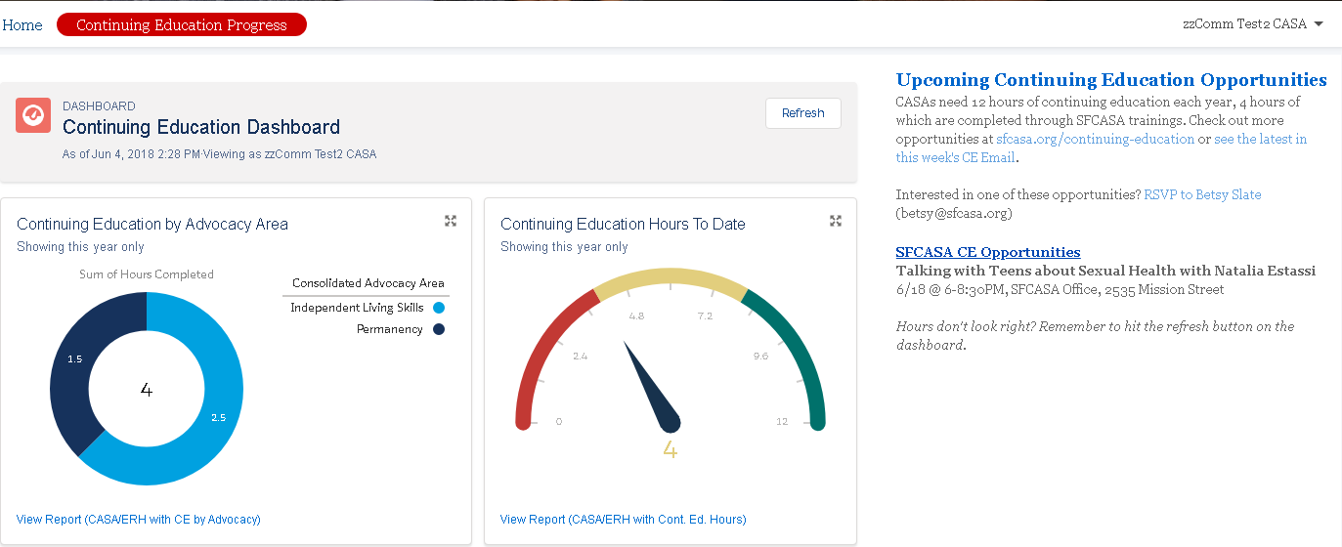
SFCASA Advocacy Areas, Definitions and Examples
- Wellbeing
  - Youth actively engage in pursuing a variety of diverse interest and experiences
  - Youth effectively manage emotions
  - Youth is able to identify and pursue goals
  - Examples: Conversations with youth about their interests and goals; advocate researches art, music or athletic opportunities on behalf of/or together with youth; advocate supports youth to express thoughts and emotions during meeting; advocate plays a game or colors with child

- Permanency
  - Youth experience caring, supportive relationships with adults and peers
  - Youth in connected to community and/or cultural groups
  - Youth displays socio-emotional skills to maintain healthy relationships
  - Examples: MAP meeting; advocates for family-finding and relative notification when appropriate, conversations with youth, their family and/or team about supportive adult relationships and relationships within their community (social-emotional permanency) and permanent plan other than long term foster care (legal permanency); youth continues to participate in a social activity that may be sustained (often combined with Wellbeing), where they are able to develop community; youth spends time with sibling(s)or extended family members

- Access to Health Care
  - Youth has regular, consistent health care. (physical, mental, and dental)
  - Youth has skills to maintain healthy physical behavior
  - Examples: Advocate takes youth to orthodontia assessment; advocate meets with youth to research and access reproductive health resources; advocate monitors and promotes access to preventative healthcare, including immunizations; advocate supports mental health connections/listens to youth express their feelings about participation in therapy; advocate supports youth to get new eyeglasses; advocate participates in Mental Health/Behavioral Health CFT or similar provider meeting

- Placement & Housing
  - Youth feels empowered to advocate for their placement and housing needs.
  - Youth is actively involved in housing decision making
  - Examples: Advocate and youth visit transitional housing programs; advocate participates in a Placement CFT; youth expresses to advocate their feelings and wishes about placement and housing; advocate communicates with AWOL youth

- Independent Living Skills (ages 14-20)
  - Youth has the skills they need to meet the requirements of independent living
  - Youth has skills to advocate for services they need/are in their best interest.
  - Advocate links youth to local ILSP; advocate and youth go to the DMV; conversations with youth about money, banking, budgets and credit reports; advocate works with youth to explore options for independent living after foster care

- Education & Career
- Youth attains developmentally appropriate grade-level achievement
- Youth feel empowered to explore their educational and career interests
- Youth participate in school activities and extracurriculars
- Examples: Advocate participates in educational meetings; advocate works with team to utilize school of origin or other education rights; advocate takes youth on outing to explore education or career interest; advocate refers youth for special education assessments; advocate researches preschool/early childhood educational opportunities and helps to enroll child; advocate and youth discuss school related issues; advocate researches and links youth to tutoring; advocate supports youth to explore JobCorps, supportive and/or independent employment opportunities; advocate attends a school-connected event in support of youth (often combined with Wellbeing); advocate and youth tour a college campus;

